A000-Asia-China-Shang-Jue-Chüeh-Bronze-1800 BCE

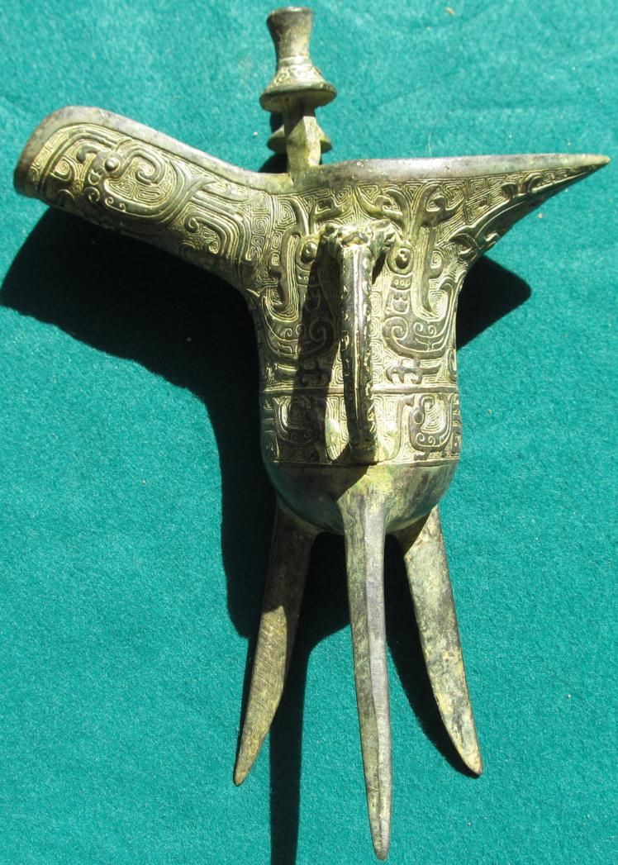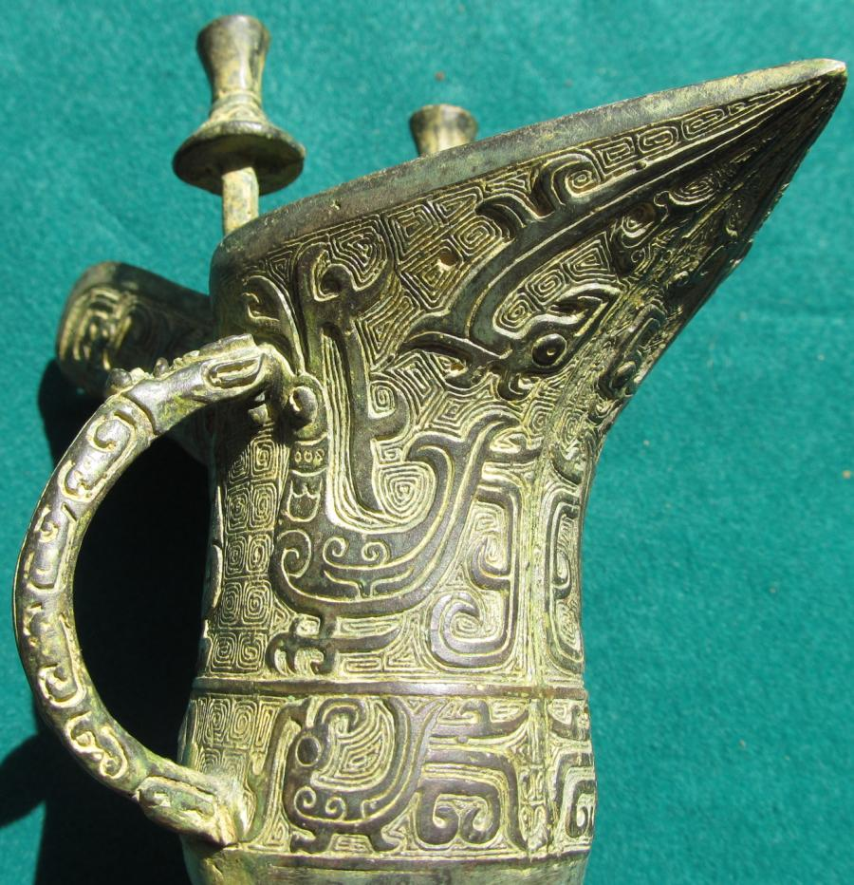

SHAPE \* MERGEFORMAT 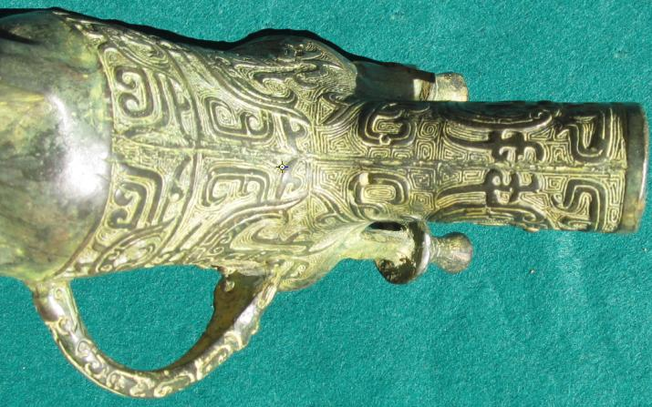 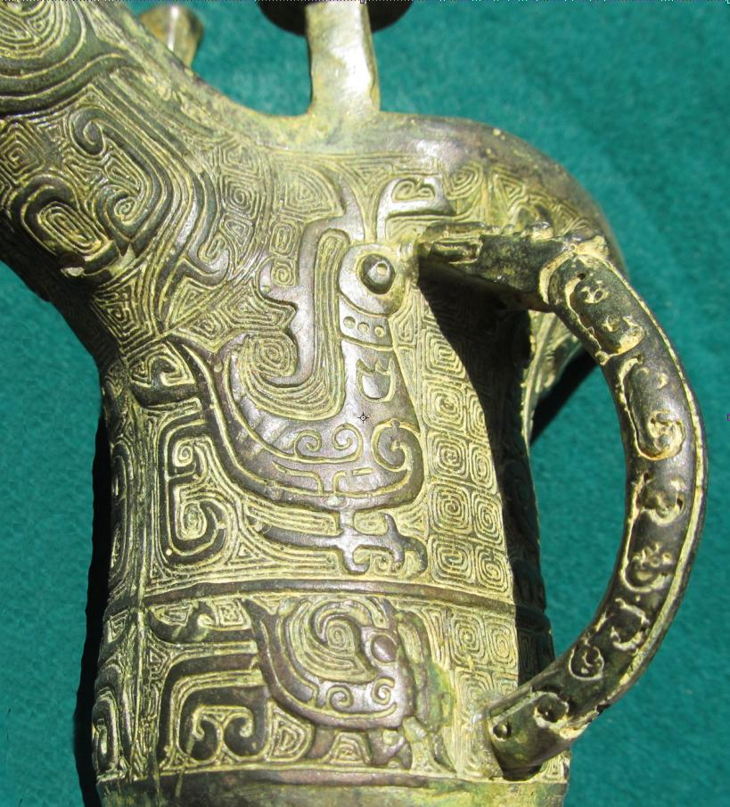

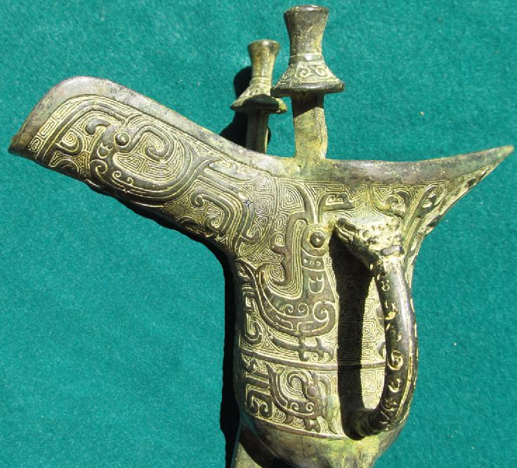

Figs. 1-5.

Case No.: 5

Accession No.

Formal Label:

**Display Description:**

The jue (chüeh, WG) is a type of ancient Chinese pitcher-like containers used for dispensing wine. The jue evolved from a pottery version in the Longshan culture (c. 2500–2000 bce) during the late Neolithic Period. Its bronze version evolved in the Shang (c. 1600–1046 bce) and early Zhou (1046–256 bce) dynasties. The rim flairs into a U-shaped spout (with capped pillars at its base) on one side and a pointed tail, or handle, flaring out from the opposite side. A taotie, or animal spirit mask, is commonly found on either side of the body, much like the jia.

Accession Number:

**LC Classification:**

Date or Time Horizon:

Geographical Area:

**Map:**

**GPS coordinates:**

Cultural Affiliation:

Media:

Dimensions:

Weight:

Condition:

Provenance:

**Discussion:**

**References:**